**Name: Abdullah Khan**

**Reg No.: SP20-BSE-042**

**Assigned Use cases: Login, Signup**

**Fully dressed Use Case**

|  |  |
| --- | --- |
| **Name** | Sign up |
| **Level** | If user forgets password, they will user forget password feature to enter new password |
| **Primary Actor** | Buyer and seller |
| **Stakeholder and Interests** | 1. Seller: Who wants to sell the product 2. Buyer: Who wants to but the product |
| **Preconditions** | 1. Buyer: User selects the buyer account for buying products 2. Seller: User selects the seller account for selling products |
| **Postconditions** | Verification email is sent after checking the format of email |
| **Main success scenario** | 1. Verification is completed 2. After verification of email account is created 3. User is logged in the account |
| **Extensions** | If user enter short password or invalid email address; error will be displayed |
| **Special requirements** | Valid Email address  Valid username |
| **Frequency of Occurrence** | Every time a new user wants to login they will have to create new account |

|  |  |
| --- | --- |
| **Name** | Login |
| **Level** | If user forgets password, they will user forget password feature to enter new password |
| **Primary Actor** | Buyer and seller |
| **Stakeholder and Interests** | Seller: Who wants to sell the product  Buyer: Who wants to but the product |
| **Preconditions** | User must have a valid account  Device must be connected to internet |
| **Postconditions** | User is successfully logged in |
| **Main success scenario** | If email is valid and password is correct user will be logged into account |
| **Extensions** | If user enter wrong password or invalid email address; error message will be displayed |
| **Special requirements** | Valid Email address  Valid password |
| **Frequency of Occurrence** | Every time a user wants to create an account for buying or selling |

**Use case Description**

**Login**

The System prompts the user for a username and password or register new account. The user enters his/her username and password. The system validates the entered username and password, making sure that the entered username is a valid username in the System, and that the required password is entered for the entered username. The user is signed in and returned to the home page as a Logged In User and the use case ends.

**Sign Up**

The system prompts the user to select a buyer or a seller account. After selecting the type of account, the System request the user for a username and password or register new account. The user selects registration option. The System prompts user for registration information, Username, password, etc*.* The user enters in their information. System verifies information and creates account and the use case ends.

**SSD**

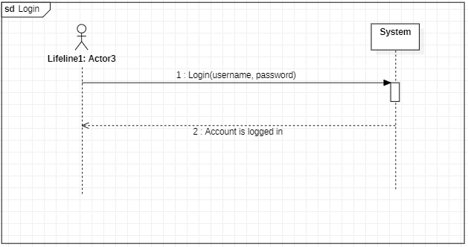

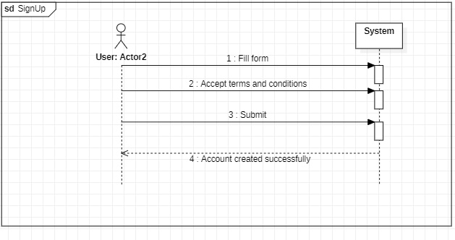

**Operation Contract**

**Operation Contract: Login**

|  |  |
| --- | --- |
| **Operation** | User has to enter username and password and checked if it is a valid user account and is logged in |
| **Cross Reference** | LOGIN |
| **Pre-Condition** | Enter information in text fields |
| **Post-Condition** | Logged In |

**Operation Contract: Sign Up**

|  |  |
| --- | --- |
| **Operation** | User has to enter username, password and email address for the creation of account |
| **Cross Reference** | SIGNUP |
| **Pre-Condition** | Enter information in text fields |
| **Post-Condition** | Email is verified by checking format of email and is sent a verification code and the account is created |